Lab Assignment -1
Date: 07 Aug 2026
- Password Strength and Cracking

Step 1: Created Two Files users.txt and passwords.txt
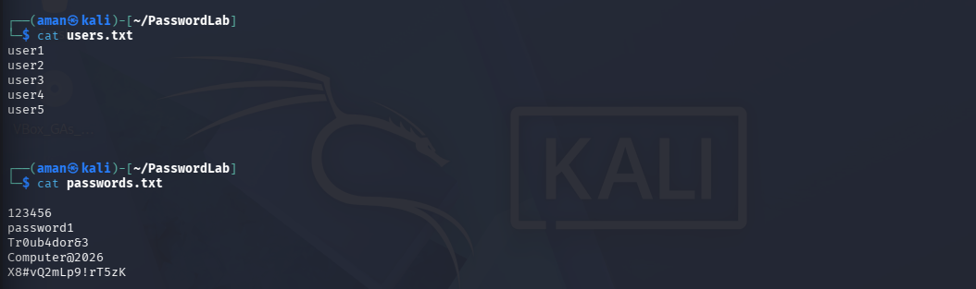

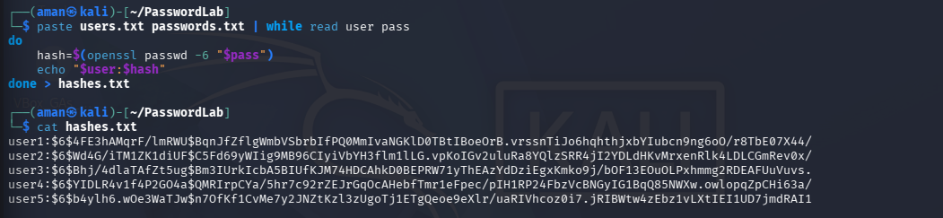
Step 2: Combined the Two Files and Created a file hashes.txt, which stores the hashes of the following passwords.

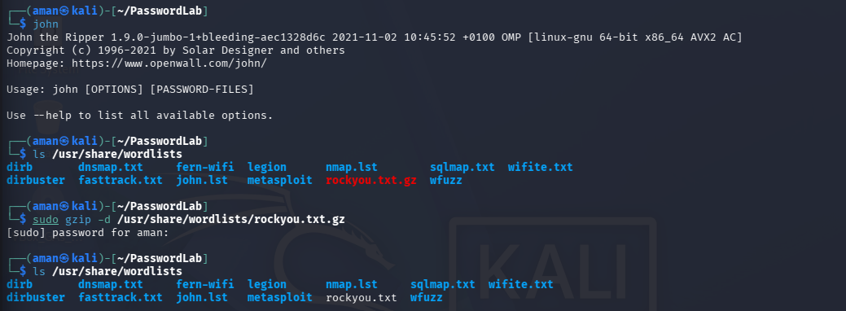
Step 3: Checked if the John the Ripper is Installed. If installed and rockyou.txt.gz is compressed then unzip it.

Question: What is rockyou.txt.gz?
Ans: rockyou.txt.gz is a compressed password dictionary that comes preinstalled with Kali Linux.
Let's break it down:
- rockyou.txt: A text file containing millions of real passwords collected from the 2009 RockYou data breach.
- .gz: Indicates the file is compressed using gzip to save disk space.

Step 4: Try to Crack the password using the Predefined Password in John the Ripper.
Command: john --wordlist=/usr/share/wordlists/rockyou.txt hashes.txt
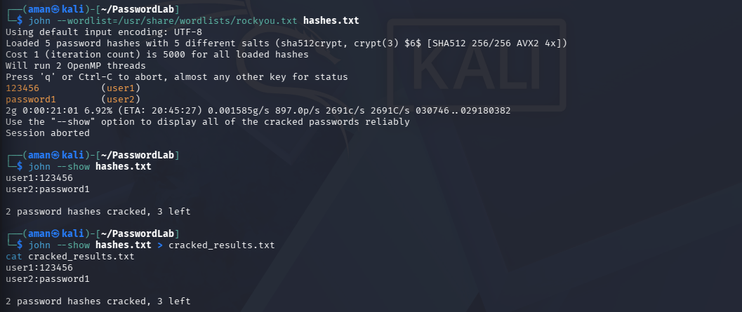

Step 5: Report on the Task
User | Password | Hash Type | Outcome | Time
User1 | 123456 | SHA-512 Crypt ($6$) | Cracked | < 1 Second
User2 | password1 | SHA-512 Crypt ($6$) | Cracked | < 1 Second
User3 | Tr0ub4dor&3 | SHA-512 Crypt ($6$) | Not Cracked | > 21 Minute
User4 | Computer@2026 | SHA-512 Crypt ($6$) | Not Cracked | > 21 Minute
User5 |  | SHA-512 Crypt ($6$) | Not Cracked | > 21 Minute
  X8#vQ2mLp9!rT5zK
Relationship between Password Complexity and Crack Resistance
The results show that password complexity has a significant impact on resistance to password-cracking attacks. Simple passwords such as 123456 and password1 were cracked almost instantly because they are common entries in the RockYou password dictionary. In contrast, passwords containing a combination of uppercase and lowercase letters, numbers, and special characters were not cracked even after 21 minutes of testing. The strongest password, a 16-character random string, provided the highest resistance because it was both long and highly random. This demonstrates that increasing password length and randomness greatly improves security against dictionary-based attacks.
- Observation: The chart shows that as password complexity increases, the time required to crack the password also increases, making complex passwords more resistant to password-cracking attacks.
- Discretionary Access Control (DAC) on Linux

Step 1: Create Two Users userA and userB.
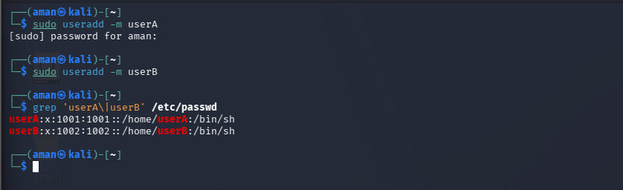
Step 2: Set passwords for the users
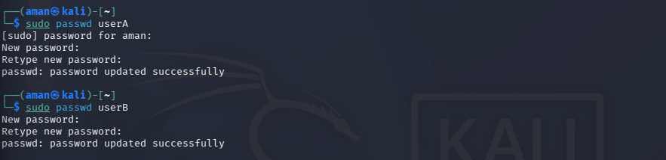
Step 3: Create the shared directory
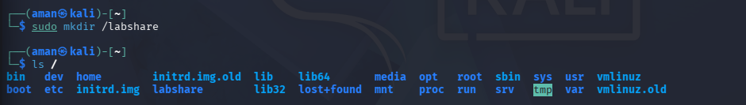
Step 4: Create a sample file
Step 5: Verify the file
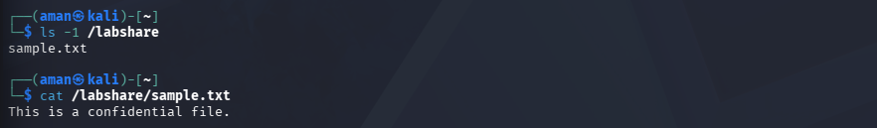

Step 6: Change the owner using chown and verify the owner
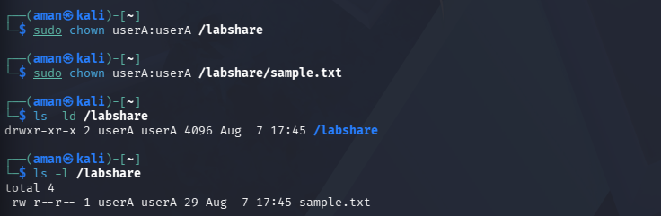

Step 7: Change permissions using chmod
We want:
- userA (owner) → Read, Write, Execute on the directory.
- Others will be restricted for now.
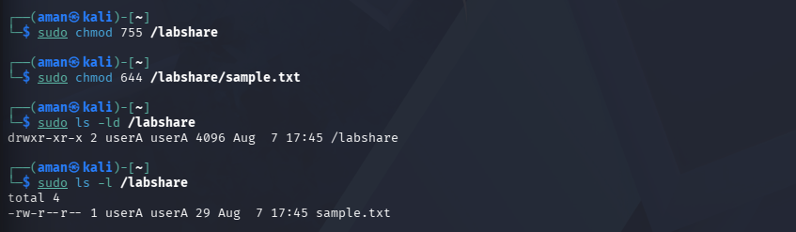

Step 8: Give userA Read/Write and userB Read-Only Access
For the Directory:

For the File:


Step 9: Verify the ACL.
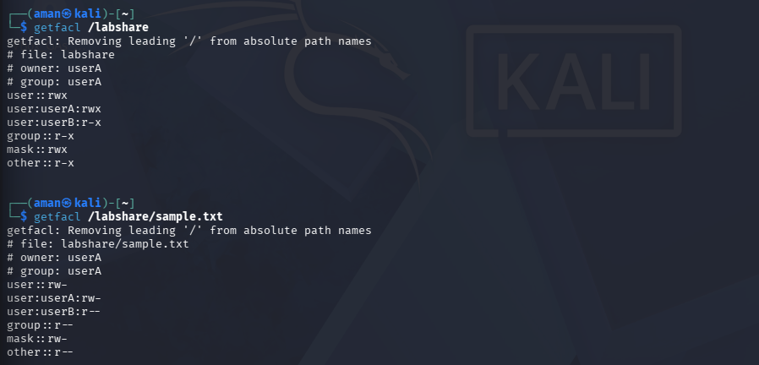
Step 10: Verify that userB can read the file

Step 11: Verify that userB cannot write into the file.
Step 12: Completely deny access to userB.
Now remove all ACL permissions for userB:
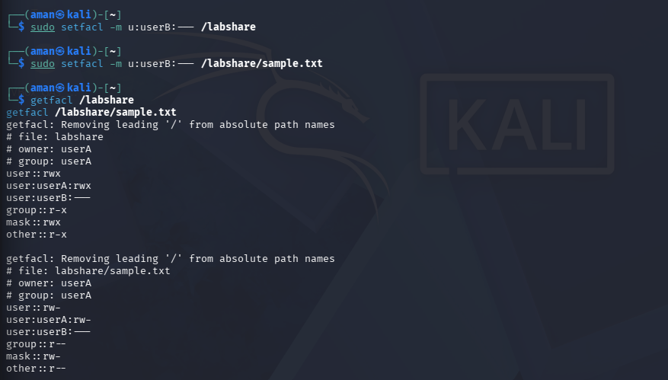
Step 13: Attempt unauthorized Access
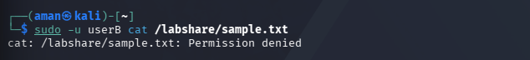

Question: why authentication and access control are necessary to preserve confidentiality, and two practical recommendations to strengthen password policy in an organization.
Access and authentication are basic techniques used for ensuring confidentiality of information in computer systems. Authentication is a technique that determines the user before access to the system, thus providing security to ensure only authorized people will have access to the system. Access control is an additional measure that limits the amount of operations available to an authorized user, which includes operations that can be seen, changed or deleted in accordance with user permissions. These techniques minimize the risk of any unauthorized access, accidental changes and malicious activities and help to protect confidential data. In the current experiment, passwords like 123456 and password1 were cracked by using John the Ripper very quickly, while other stronger passwords could not be hacked at all during the experiment time. Additionally, the Linux Discretionary Access Control (DAC) showed how access level depends on file permissions and Access Control Lists (ACL) and different users have access to different files and information; for instance, userA had permissions to read and write a file, while userB had read permissions at first and then was prohibited to access the file, receiving "Permission denied" message.
There are two recommendations to improve an organization's password policy:
- Force employees to use long and unique passwords or passphrases, including upper-case and lower-case letters, numbers and special characters.
- Introduce multi-factor authentication and do not allow any commonly used passwords.

